**MongoDB Task - 2**

**1.Find all the topics and tasks which are taught in the month of October**

**MongoDB Compass:**

**Topics were taught in the month of October:**

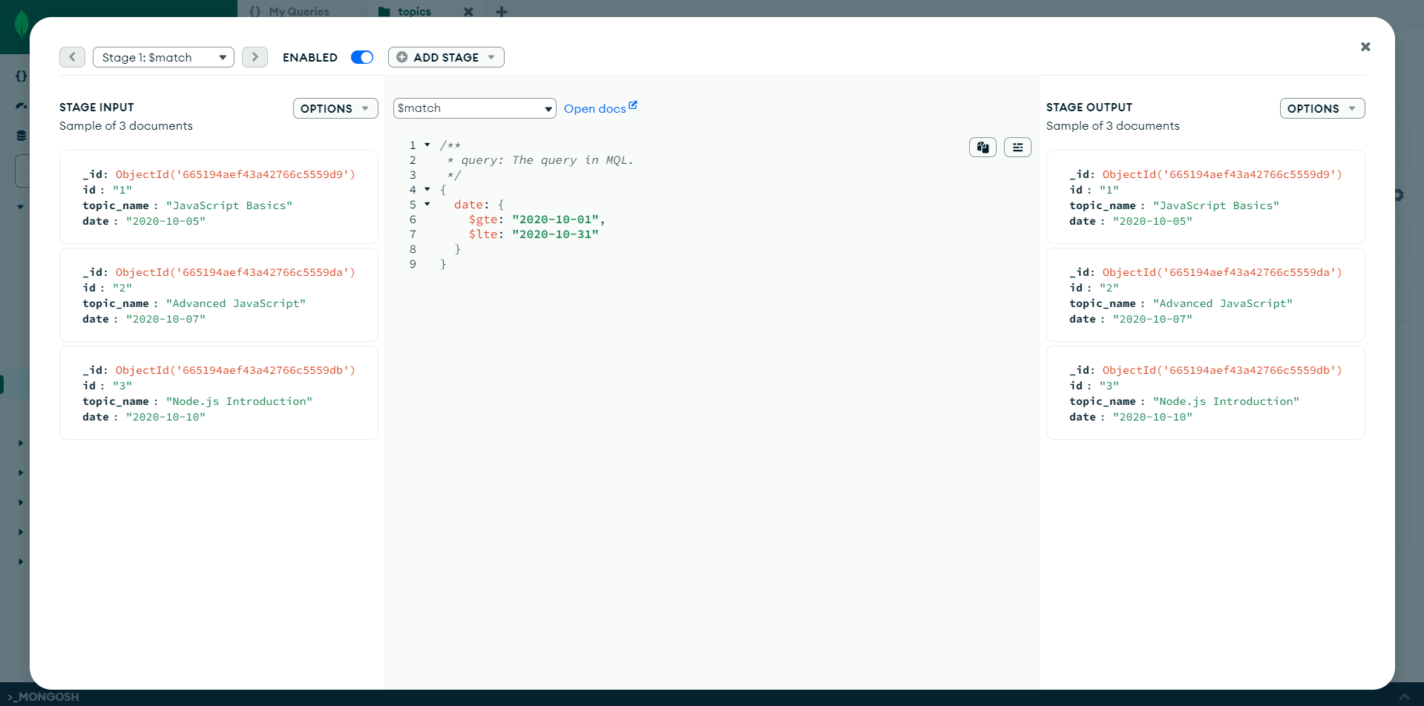

**Tasks were given in the month of October**

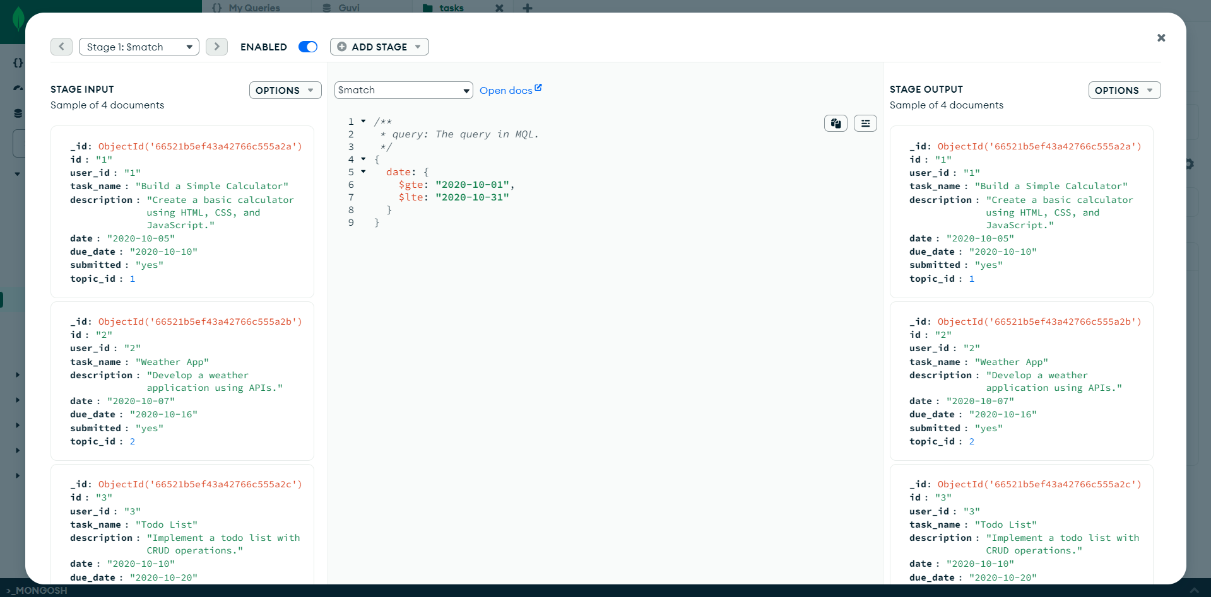

**Shell:**

**Topics were taught in the month of October:**

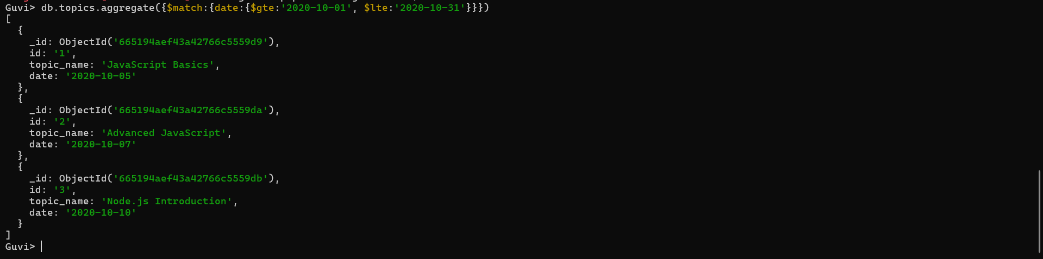

**Tasks were given in the month of October**

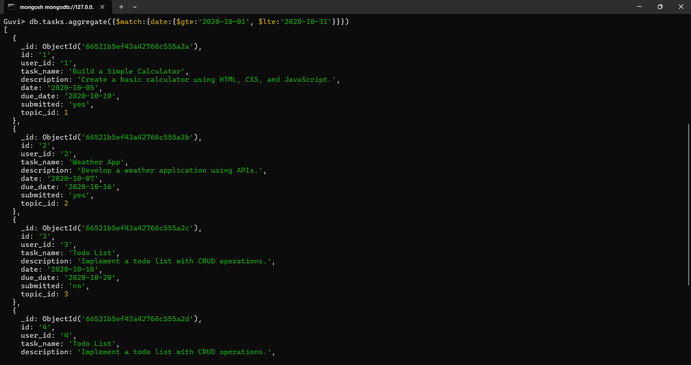

**2.Find all the company drives which appeared between 15 oct-2020 and 31-oct-2020**

**MongoDB Compass:**

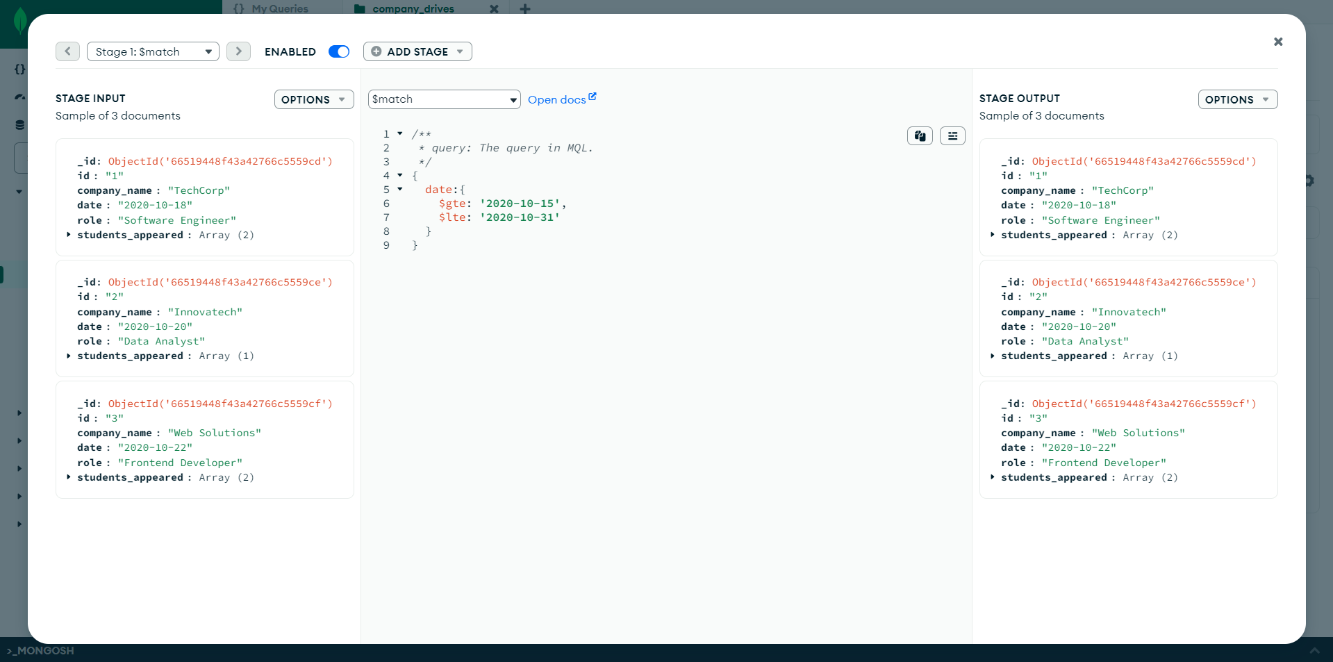

**Shell:**

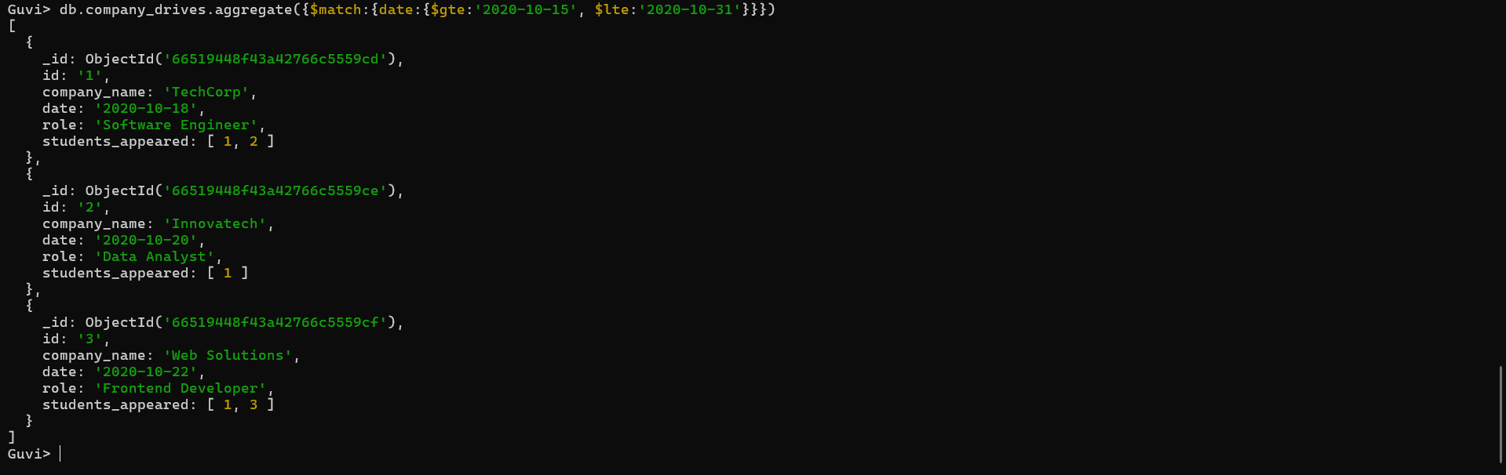

**3.Find all the company drives and students who are appeared for the placement**

**MongoDB Compass:**

$lookup stage:

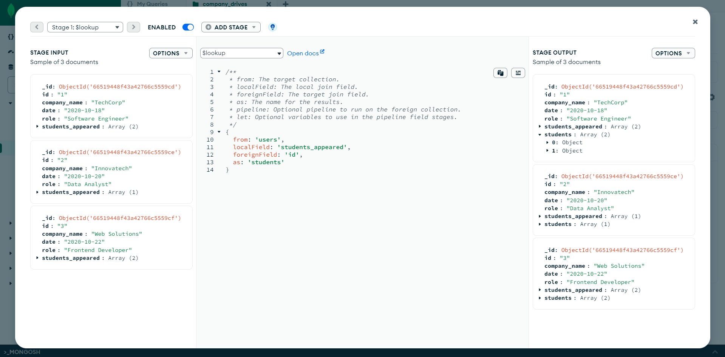

$unwind stage:

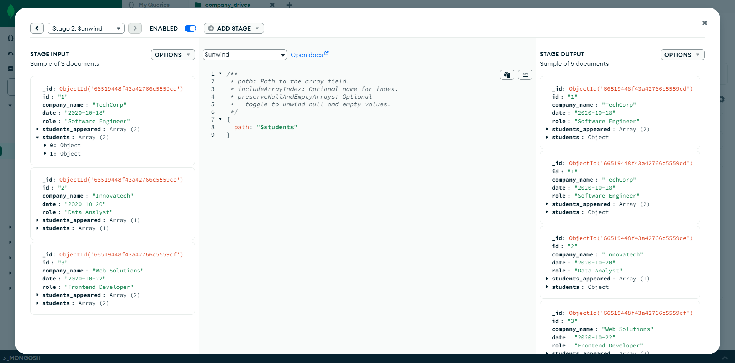

$project stage:

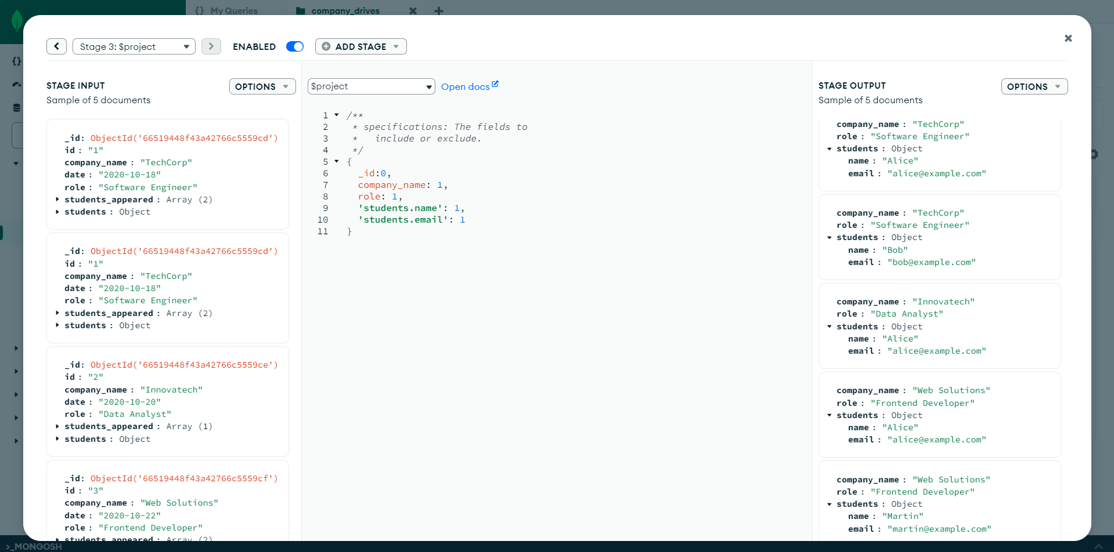

**Shell:**

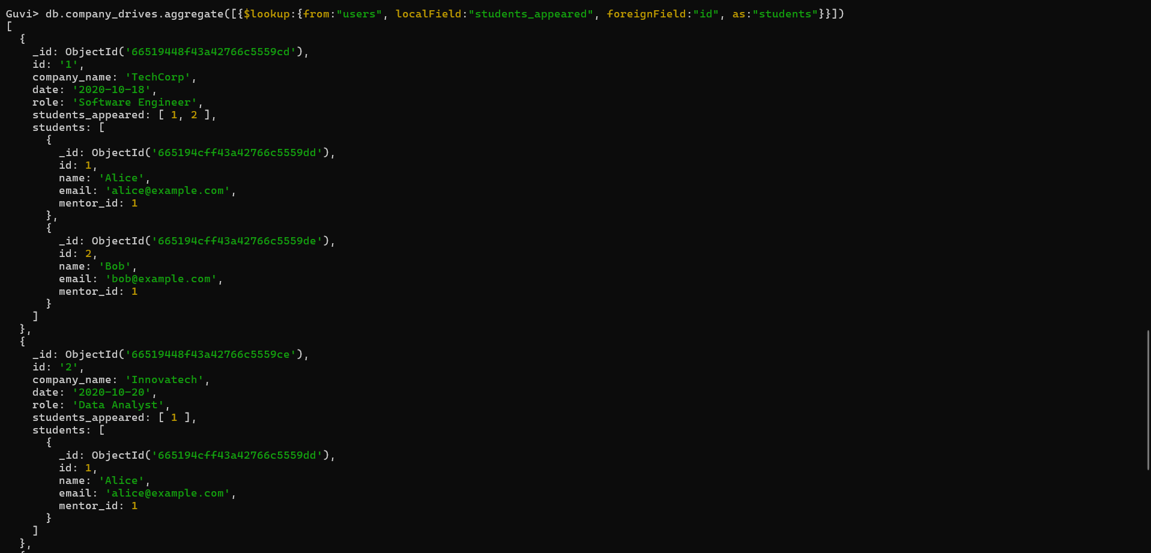

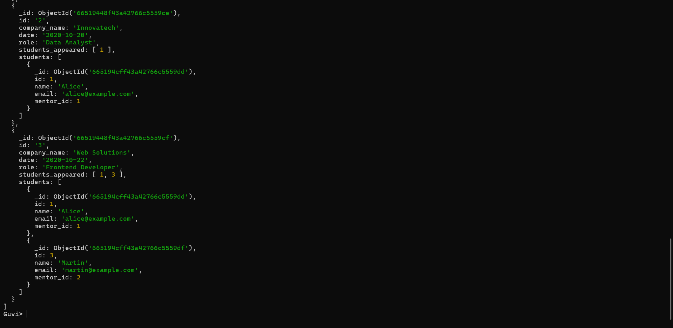

**4.Find the number of problems solved by the user in codekata**

**MongoDB Compass:**

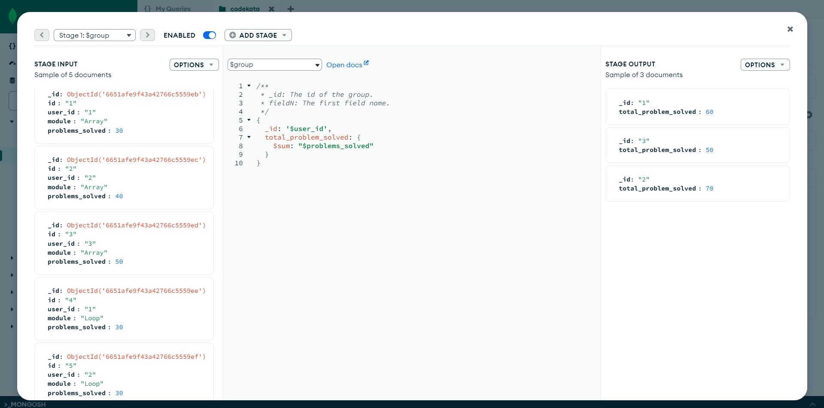

**Shell:**

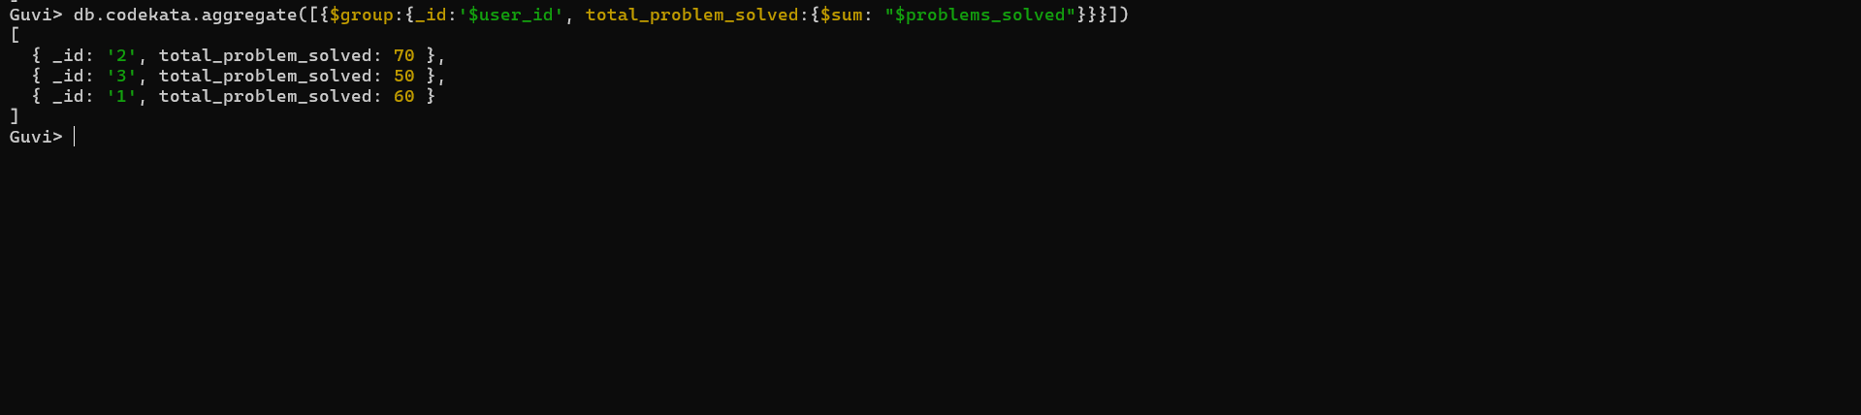

**5.Find all the mentors with who has the mentee's count more than 15**

**MongoDB Compass:**

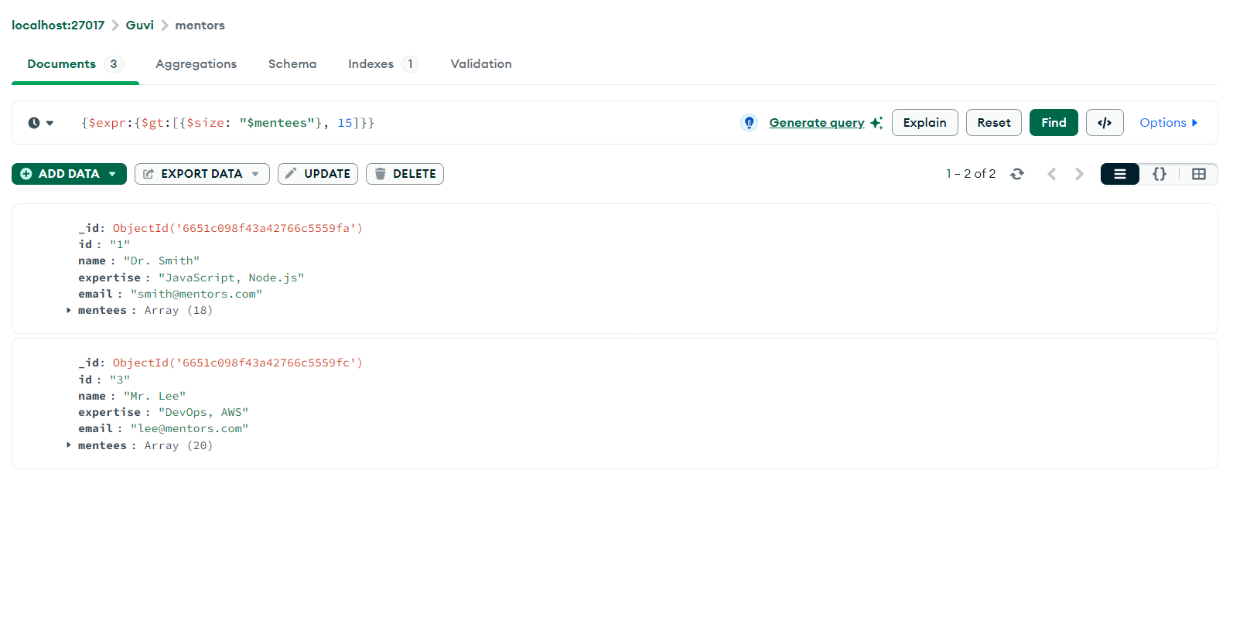

**Shell:**

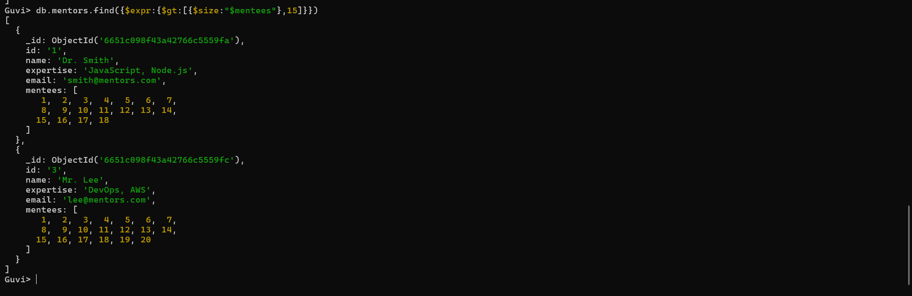

**6.Find the number of users who are absent and task is not submitted between 15 oct-2020 and 31-oct-2020**

**MongoDB Compass:**

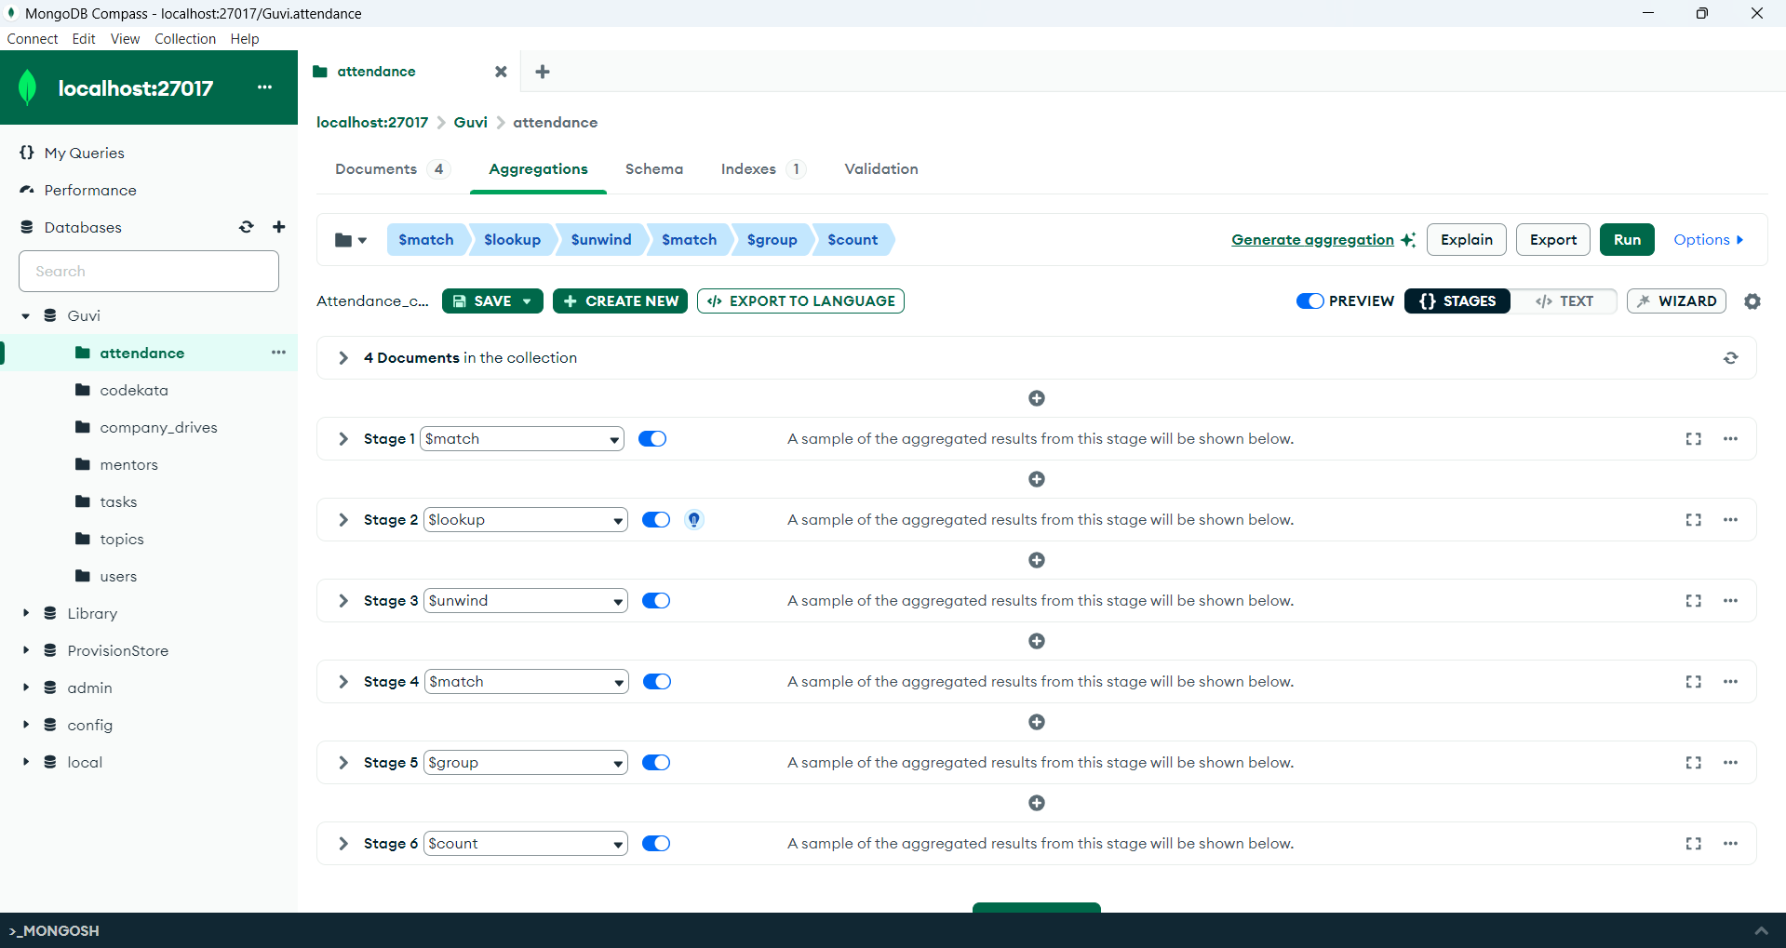

1.$match Stage

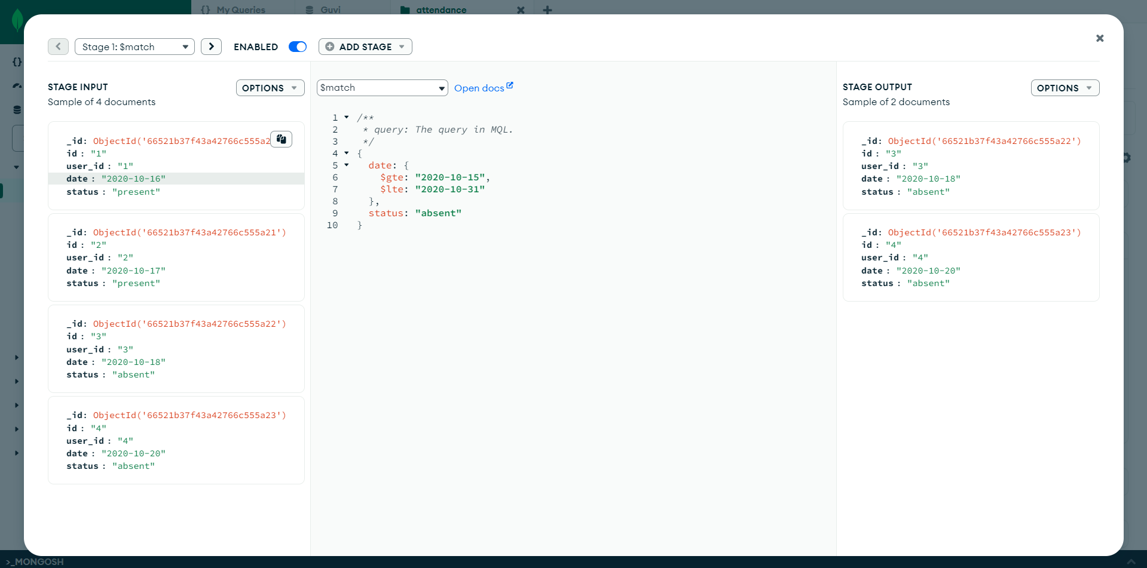

2.$lookup Stage:

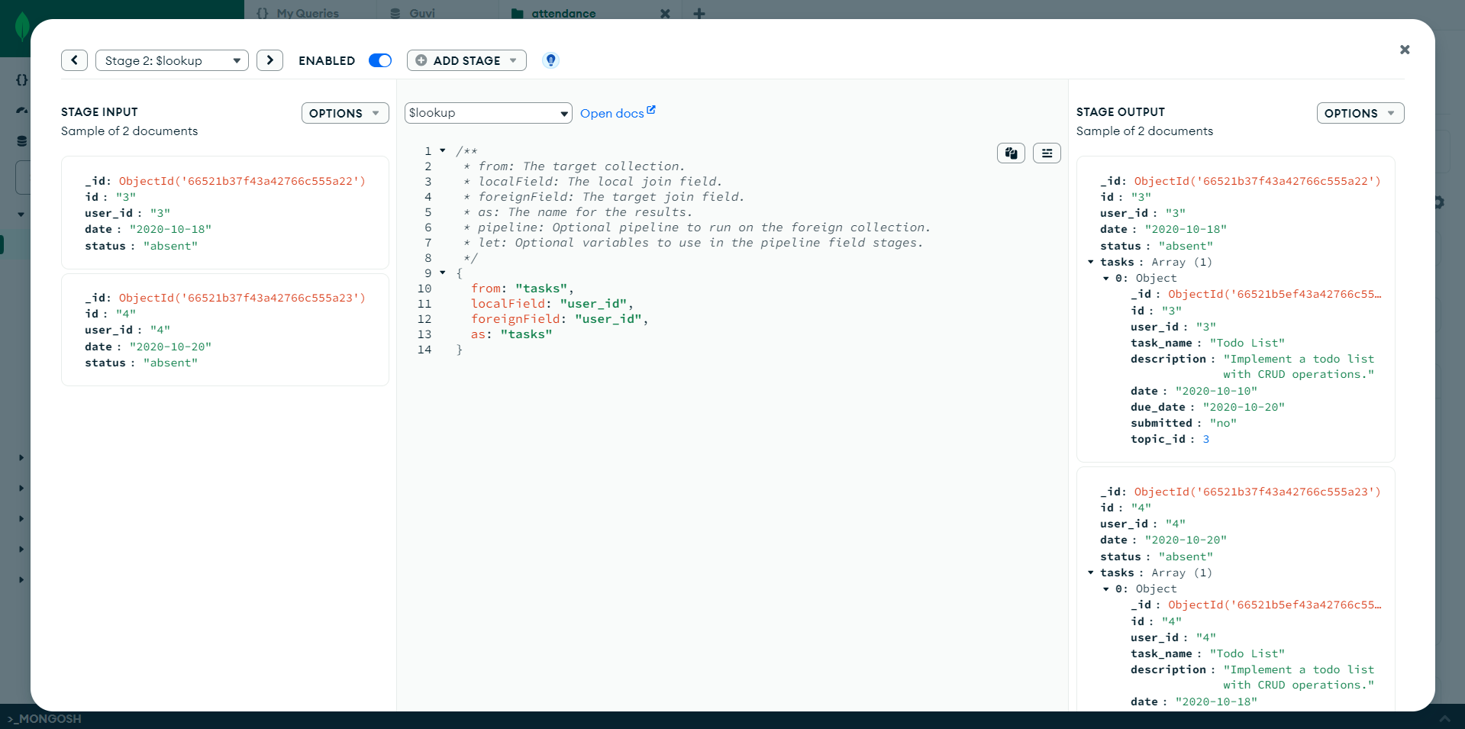

3.$unwind stage

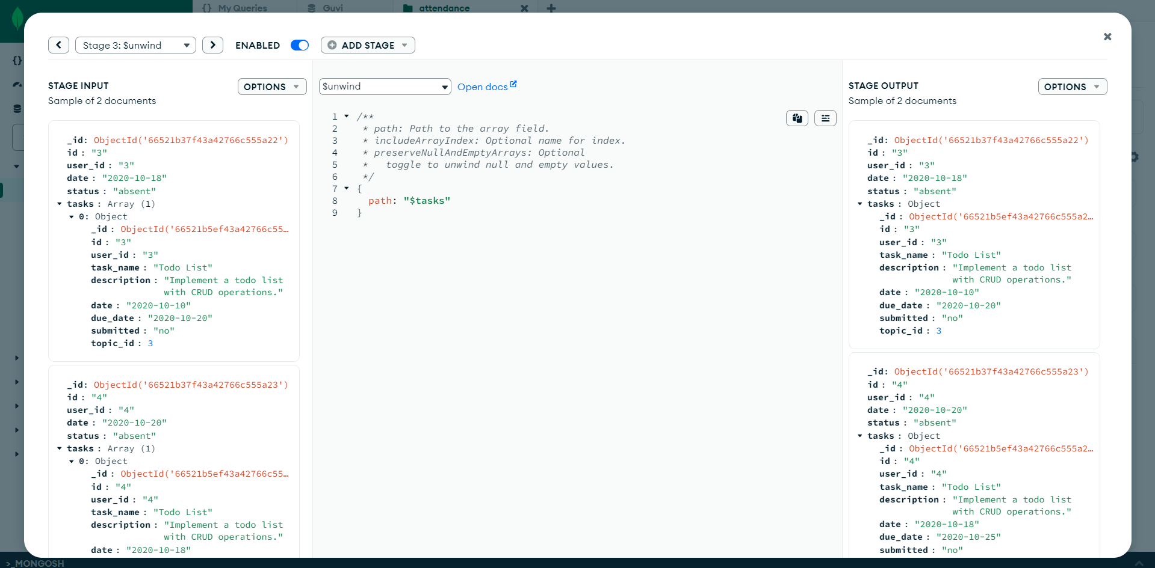

4.$match stage:

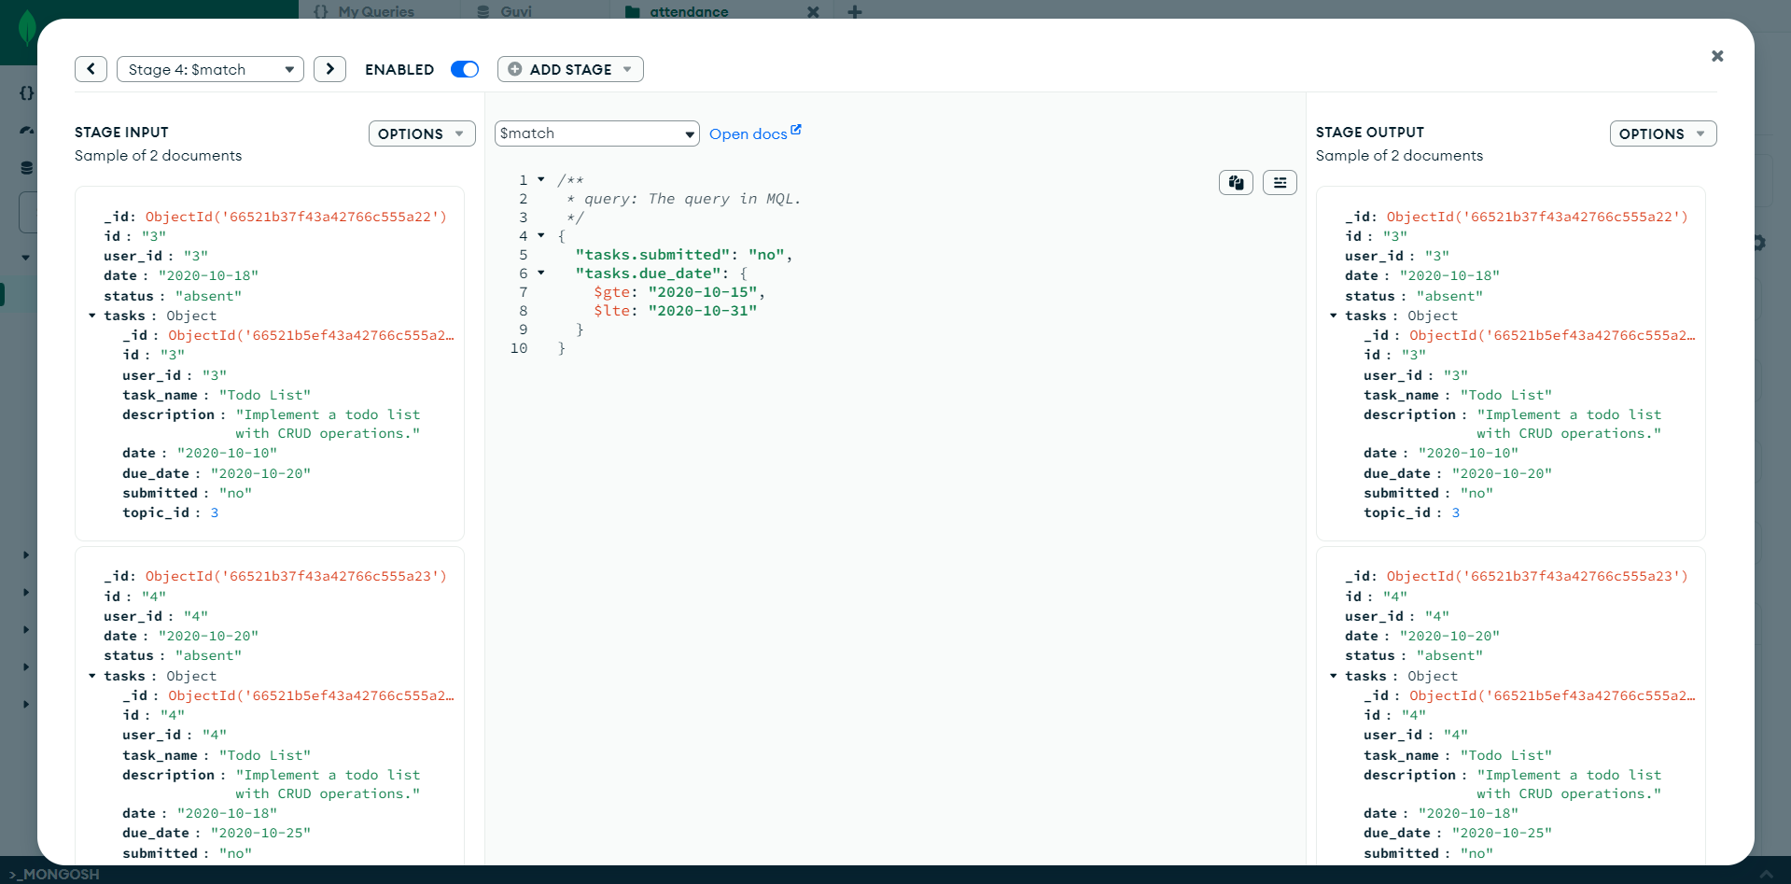

5.$group stage:

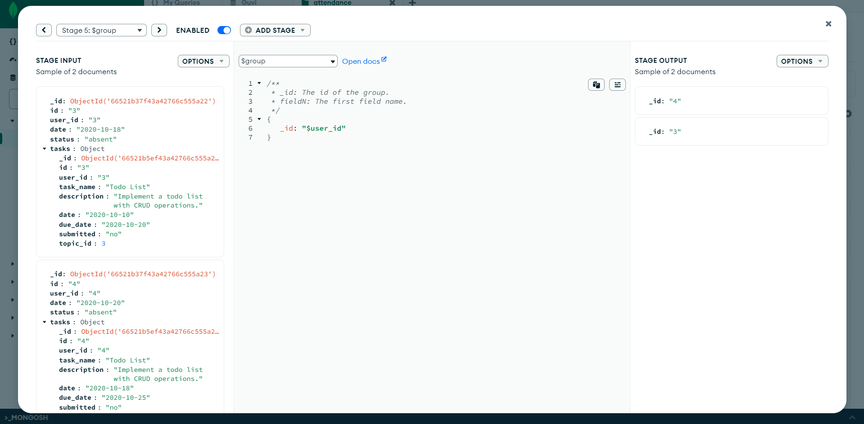

6.$count stage:

